
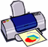


Our band sizes – print and cut out to find your size!
Trying on a paper version of our bands is a great way to check your size. (We’ve found that some children need the large size and vice versa.) Simply print this page on a letter size sheet of paper (8.5x11) and cut on dotted lines to compare the bands sizes to your wrist.

TODDLER = 5.8 inches = 147 mm

CHILD = 6.9 inches = 175 mm

ADULT = 8.0 inches = 203 mm

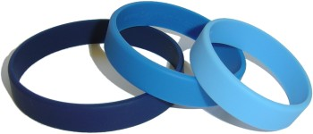
Contact us with any questions at email@sayitbands.com

